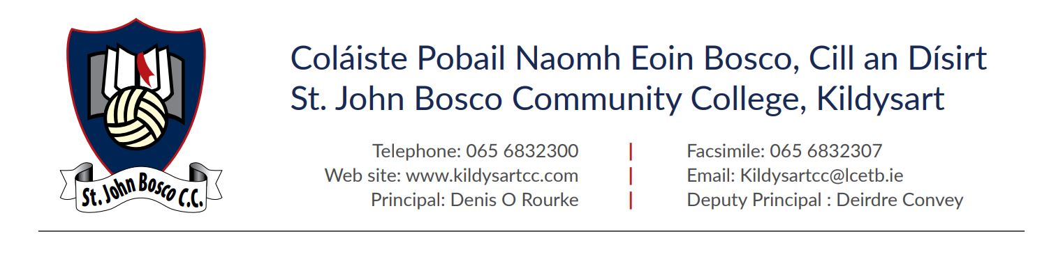

Modern Foreign Language Department European Cultural Trip – Brussels

Dear Parent/Guardian,
We are writing to share some news regarding an upcoming educational trip for our Transition Year students. The MFL Department is organizing a 4-day visit to Brussels, Belgium, taking place from December 14th to December 17th.
Thanks to partial funding secured through our schools Erasmus+ program, we are able to offer this immersive European cultural and language experience at a significantly reduced rate.
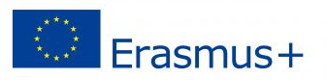

Trip Overview

Dates: December 14th – December 17th
- Group: Transition Year students accompanied by 2 teachers
- Accommodation: MEININGER Hotel Brussels Gare du Midi (Bed & Breakfast basis; multi-bed rooms for students)
- Travel & Transport:
  - Return flights from Dublin to Brussels
  - Dedicated local coach hire (up to 12 hours per day)
- Comprehensive Travel Insurance: Full group travel insurance is included.
Key Activities & Visits:
- Guided City Tour: A 3-hour guided walking tour of Brussels, including a visit to the iconic Grand Place.
- European Institutions: A visit to the Parliamentarium to learn about the inner workings of the European Union.
- Cultural & Historical Landmarks: Exploration of the famous Atomium.
- Interactive Experience: A visit to Choco-Story Brussels (The Chocolate Museum).

Cost to Students & Payment Details
While the core funding for this trip is covered by Erasmus+, we are requesting a student contribution of €150 per pupil to cover the remaining costs.

Next Steps
- A link has been sent to each student on the Google Classroom Platform to pay the €150 student contribution directly to the tour company. As flight prices are constantly rising, the tour company require payment before Fri 9th to secure the flights as soon as possible. *Please let us know if this becomes an issue.
- Making this payment also confirms consent to travel.
- Its important that your child has a valid passport and European Health Insurance Card to travel. These items will be needed shortly.

Online Information Briefing
We will host a brief online informational briefing closer to the departure date to share exact flight times, packing guidelines, and final itineraries. Should you have any questions in the meantime, please feel free to contact the school

Kind regards,
The MFL Department – Ms J Ryan & Ms S Fitzgerald

